Use Case
Fact_finance_budgets is a dimension in a data warehouse that analyzes projects. Attributes of those budget records will change occasionally and when they do, we want to track them by maintaining history, creating a new row with the new budget data (SCD Type 2).
Step 1: We need 2 sources. First is the incoming new budget records, which is this Paraquet file:
EmpID Region Status Function Level Role StartDate EndDate
1234 SER A ADM A Finance 1/1/2000
1345 SER A ADM A Finance 4/5/2008
1789 PNW A ENG N Engineer 7/9/2011
2349 PNW I ENG N Engineer 9/8/1999 4/1/2019
8382 NER A RAD A Marketing 4/5/1998
Advertisement
The 2nd source will be the existing Fact_finance_budgets table (Dimaccount) in the existing data warehouse, which is in my Azure SQL Database:
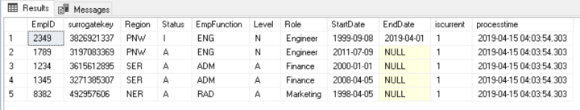

Basic SCD Type 2 Logic
- Lookup incoming new Budget records against existing records in the Fact_finance_budget table
- If they are new budgets, then create a new surrogate key and insert the row into the Fact_finance_budget table
- If the Budget member already exists, then set the “iscurrent” flag to 0 and update the End Date and Status attributes in the existing tow
- Add a new row for the Budget with the new member attributes, set “iscurrent” to 1
The top row in the Data Flow is the “new budget” stream.
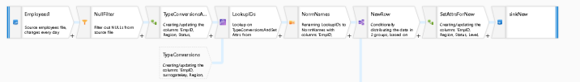

New Rows

  - The Budget new file source is set to delete upon completion and uses a wildcard path to find the latest CSVs in a folder
  - 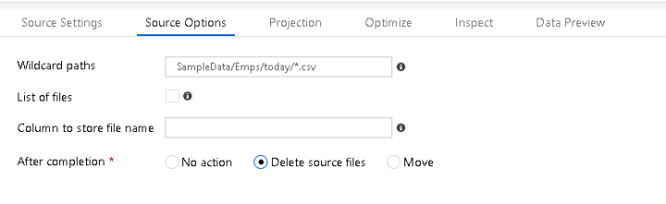
  - The Null Filter removes any extraneous rows from the source due to extra newlines using the Filter tranformation
  - The TypeConservation Derived Column transformation norms the data types of the incoming CSV string-types to logical types and also sets an ETL processtime field to currentTimeStamp(). I use this in all of my ETL processes for tracking & logging.
  - LookupIDs will find matching budgets from the Budget source, matching on BudgetId. This is the 2nd source:
  - 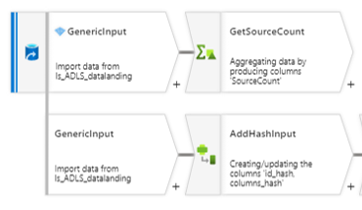
  - I also used a type conversion Derived Column to again norm data types by casting each field to ensure we are using the same logical types on this 2nd source from the database table.
  - NormNames is a “Select” transformation which is used for aliasing, renaming, and column selectivity. I am removing any columns from the Lookup that I do not wish to flow through here as well as removing the FQNs, keeping simple names with no namespace.
  - NewRow is a Conditional Split which is used from the results of the Lookup to decide if this is a new incoming budget. If the “iscurrent” field is NULL, then we know it is new because that column will only be present from an existing database row.
  - Now that we know the empID is new, we can create a new row for Insert. The Sink will have “Allow Inserts” as the only database option for the DimEmp table and the SetAttrsForNew is a Derived Column that will set “iscurrent” to 1 and will generate a new Surrogate Key using this formula:
  - toString(crc32(EmpID,EmpFunction))
  - Notice that I did not use the Surrogate Key transformation. In this case, I am not seeding all new values. The SK in Data Flows acts as a sequence generator. In this case, I wish to use pure non-business keys that are not sequential.

Existing Rows
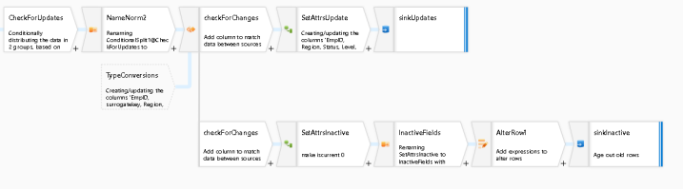We’ll know that the incoming row is an update to an existing member because we found a value (not NULL, could be any value) from the Conditional Split in the “checkForUpdates” branch.

    - NameNorm2 is another Select transform that again picks the columns we’re interested in and allows us to remove duplicate columns that originated from the Lookup
    - CheckForChanges is an Exists transformation and is how we’re going to make a determination that there was a change in any of the existing member properties that we are interested in.
    - I decided to only trigger an update to the table if we see a change in Region, Status, Role, Level, or End Date using this formula in Exists:
    - NameNorm2@EmpID == TypeConversions@EmpID &&
(
NameNorm2@Region != Fact_finance_budgets@Region ||
NameNorm2@Status != Fact_finance_budgets@Status ||
NameNorm2@Level != Fact_finance_budgets@Level ||
NameNorm2@Role != Fact_finance_budgets@Role ||
NameNorm2@EndDate != Fact_finance_budgets@EndDate
)
    - If any rows have changes to those attributes, we’ll write a new row by setting “iscurrent” to 1 in the SetAttrUpdate Derived Column, marking this row as the active member
    - On the “CheckForChanges” Exists transform, select “New Branch”. This will create a separate copy of that data stream so that we can use any matches from that Exists check to turn the existing rows to inactive.
    - SetAttrsInactive is a Derived Column that sets “iscurrent” to 0, marking the existing member row as not current.
    - I use a Select transformation called “InactiveFields” so that I choose only the columns that I wish to update to the existing, now inactive, version of the Budget member.
    - Alter Row is added next as a transformation that will set my database policy on this stream to “Update”. The formula to update is simply “true()”. This allows us to update the existing member row.
    - The Sink is set to only “allow updates” and the mapping only maps the fields that need to be updated to the existing dimension members:
    - 